Ideation Phase
Empathize & Discover — Empathy Map Canvas
Date | 8 October 2026
Student Name | OviyaShree
Project Name | Metro Ticket Generating System in ServiceNow
Maximum Marks

Empathy Map Canvas
Dimension | Passenger Perspective
Says | I need a fast way to book a metro ticket without waiting in a queue.
Thinks | I want the fare to be correct and the QR ticket to work at the gate.
Does | Opens the portal, selects source and destination stations, enters travel details and submits.
Feels | Wants a quick, convenient and reliable travel experience.
Pain Points | Long queues, manual fare errors, paper tickets and slow counter service.
Needs / Goals | Automated fare calculation, instant digital QR ticket and simple booking.
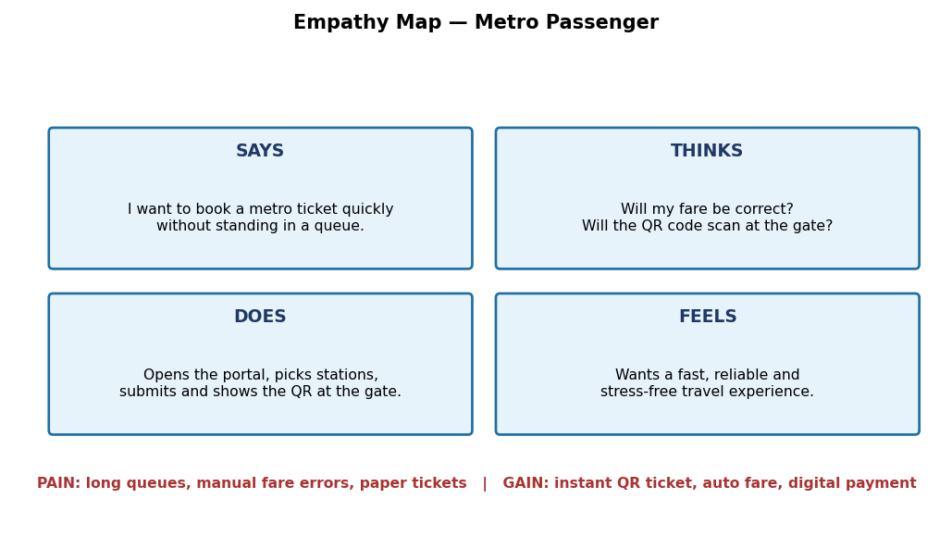
Figure 1: Passenger perspective empathy map representation.

